Report
CO4_AT3 Assessment
Q22. Principle of Optimality vs Greedy Choice Property – Conceptual Comparison
1. Aim
To compare the Principle of Optimality used in Dynamic Programming with the Greedy Choice Property used in Greedy algorithms and analyze their influence on algorithm design, correctness, and optimality in resource allocation problems.

2. Problem Statement
Resource allocation problems require limited resources to be distributed efficiently in order to maximize benefits or minimize costs. Different algorithmic paradigms can be used to solve such problems.
Dynamic Programming relies on the Principle of Optimality, whereas Greedy algorithms rely on the Greedy Choice Property. Understanding the differences between these principles is important for selecting the correct algorithmic approach.

3. Objectives
- Understand the Principle of Optimality.
- Understand the Greedy Choice Property.
- Compare Dynamic Programming and Greedy approaches.
- Identify conditions where both properties hold.
- Analyze limitations when either property fails.
- Study their impact on correctness and optimality.
- Select suitable paradigms for solving optimization problems.

4. Principle of Optimality
The Principle of Optimality states that:
An optimal solution to a problem contains optimal solutions to its subproblems.
This principle forms the foundation of Dynamic Programming.
In a resource allocation problem, if a decision is made at the current stage, the remaining resources must also be allocated optimally to obtain the overall optimal solution.
Dynamic Programming solves overlapping subproblems and stores their solutions to avoid repeated computation.
Examples
- 0/1 Knapsack
- Matrix Chain Multiplication
- Longest Common Subsequence
- Floyd-Warshall Algorithm

5. Greedy Choice Property
The Greedy Choice Property states that:
A globally optimal solution can be obtained by making a locally optimal choice at each step.
A Greedy algorithm makes the best immediate choice without reconsidering previous decisions.
For a resource allocation problem, the algorithm selects the resource allocation that appears most beneficial at the current stage.
Examples
- Fractional Knapsack
- Activity Selection
- Huffman Coding
- Prim's Algorithm
- Kruskal's Algorithm

6. Comparison Between the Two Principles
Feature | Principle of Optimality | Greedy Choice Property
Main Approach | Dynamic Programming | Greedy Algorithm
Decision Making | Considers multiple choices | Selects locally best choice
Subproblems | Must have optimal substructure | Requires safe greedy choices
Previous Decisions | May be reconsidered through states | Usually never reconsidered
Storage | Stores intermediate results | Usually requires less memory
Complexity | Often higher | Usually lower
Optimality | Guaranteed when recurrence is correct | Guaranteed only when greedy property holds
Examples | 0/1 Knapsack | Fractional Knapsack

7. Resource Allocation Example
Consider a situation where a company has limited resources and wants to maximize total profit.
There are two possible approaches.
Dynamic Programming Approach
Dynamic Programming considers different combinations of resource allocation.
It:
- Divides the problem into subproblems.
- Calculates optimal solutions for smaller problems.
- Stores intermediate results.
- Combines subproblem solutions.
- Produces a globally optimal solution.
This approach is useful when an immediate best choice may not lead to the overall best result.

Greedy Approach
The Greedy approach:
- Selects the resource with the highest immediate benefit.
- Allocates resources to that choice.
- Repeats the process for remaining resources.
It is faster but may fail if the locally optimal choice prevents a better global solution.

8. Conditions Where Both Properties Hold
Both the Principle of Optimality and Greedy Choice Property hold when:
- The problem has optimal substructure.
- A locally optimal decision can safely be part of a global optimum.
- Future decisions are not negatively affected by the current greedy choice.
Examples include:
Minimum Spanning Tree
Algorithms such as Prim's and Kruskal's use safe greedy choices while maintaining global optimality.
Shortest Path with Non-Negative Edge Weights
Dijkstra's algorithm uses greedy choices and optimal substructure.
Fractional Knapsack
Selecting items with the highest profit-to-weight ratio leads to an optimal solution.

9. When Greedy Choice Property Fails
The Greedy approach may fail when a locally optimal choice does not produce a globally optimal solution.
Example: 0/1 Knapsack
In 0/1 Knapsack, an item must either be selected completely or rejected.
Selecting the item with the highest profit-to-weight ratio may prevent a better combination of items from being selected.
Therefore:
- Greedy approach may not guarantee optimality.
- Dynamic Programming is preferred.

10. When Dynamic Programming Is Required
Dynamic Programming is appropriate when:
- The problem has optimal substructure.
- Multiple decisions must be compared.
- Subproblems overlap.
- A greedy decision cannot be proven safe.
Dynamic Programming explores possible states and ensures the optimal solution is selected.
However, it may require:
- More memory.
- More computation time.
- More complex implementation.

11. Impact on Correctness
Algorithm correctness depends on whether the chosen design principle is valid for the problem.
Dynamic Programming
Correctness depends on:
- Correct identification of subproblems.
- Proper recurrence relation.
- Correct base cases.
- Optimal substructure.
Greedy Algorithm
Correctness depends on proving that:
- Every greedy choice is safe.
- A greedy choice can be part of an optimal solution.
- Future decisions do not invalidate the current choice.
Without such proof, a Greedy algorithm may produce a suboptimal solution.

12. Impact on Optimality
Scenario | Dynamic Programming | Greedy
Optimal substructure exists | Produces optimal result | May or may not
Greedy choice property exists | Can solve optimally | Produces optimal result
Local choice affects future options | Handles effectively | May fail
Complex decision dependencies | Suitable | Less suitable
Dynamic Programming generally provides stronger guarantees for complex optimization problems, while Greedy algorithms are more efficient when their greedy-choice property can be proven.
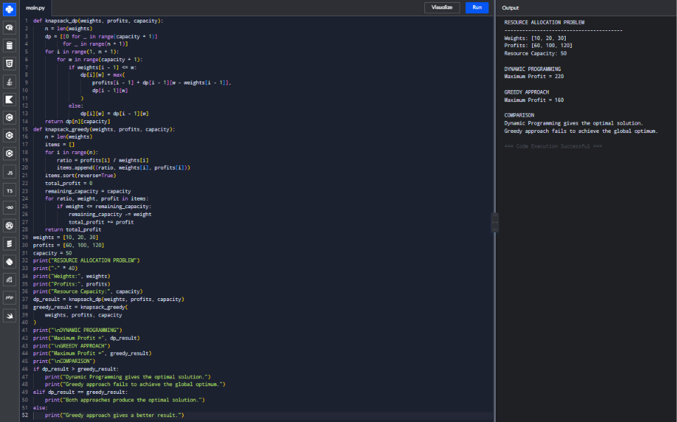
13. Limitations
Limitations of Dynamic Programming
- Requires additional memory.
- Can have high computational complexity.
- State design may be difficult.
- Not suitable when a simple greedy solution exists.
Limitations of Greedy Algorithms
- Cannot solve every optimization problem.
- Local optimum may not produce global optimum.
- Requires proof of the greedy-choice property.
- Cannot easily correct a wrong earlier decision.

14. Choosing the Right Paradigm
The following guidelines can help select an appropriate approach:
Choose Greedy When:
- A locally optimal choice is proven safe.
- Decisions do not need reconsideration.
- Fast execution is required.
- The problem satisfies the Greedy Choice Property.
Choose Dynamic Programming When:
- Multiple choices must be explored.
- The problem has overlapping subproblems.
- Earlier decisions affect future results.
- Greedy choices cannot guarantee optimality.

15. Key Insights
- Both paradigms are used for optimization problems.
- Dynamic Programming depends on optimal substructure.
- Greedy algorithms depend on locally optimal choices leading to global optimality.
- Every problem with optimal substructure is not necessarily solvable using Greedy algorithms.
- Dynamic Programming is generally more computationally expensive.
- Greedy algorithms are simpler and faster when applicable.
- The choice of algorithm should be based on mathematical properties of the problem rather than implementation simplicity.

16. Conclusion
The Principle of Optimality and Greedy Choice Property are two important concepts in algorithm design. Dynamic Programming uses optimal solutions to subproblems to construct a global optimum, whereas Greedy algorithms make locally optimal decisions with the expectation that they lead to a globally optimal solution.
Greedy algorithms are generally faster and use less memory, but they are only correct when the Greedy Choice Property can be proven. Dynamic Programming is more flexible and reliable for complex problems with overlapping subproblems, although it may require additional computation and memory.
Therefore, selecting the correct paradigm requires analyzing the mathematical structure of the problem. When locally optimal decisions are guaranteed to be globally optimal, a Greedy approach is preferred. When decisions are interdependent and multiple alternatives must be considered, Dynamic Programming is the better choice.

